 

CS-114 Fundamentals of Programming (2+1)

DE-41 EE Semester 1

Fall 2019

**LAB REPORT # 09**

|  |  |
| --- | --- |
| **Submitted by** | **Roll No** |
| Ayesha Javaid | 285151 |
| Syndicate A |  |

Instructor In-charge: Dr. Saad Rehman

DEPARTMENT OF COMPUTER & SOFTWARE ENGINEERING

College of Electrical and Mechanical Engineering (CEME)

National University of Sciences and Technology (NUST)

**Task 1:**

Write a program that accepts five integer values in array using pointers.

**Code:**

#include<iostream>  
  
  
using namespace std;  
  
   int main()  
    {  
     int arr[5],i;  
     int *p=arr;  
     cout<<"Enter five numbers separated by space:";  
     cin>>*p>>*(p+1)>>*(p+2)>>*(p+3)>>*(p+4);  
     cout<<"Your numbers are:\n";  
     for(i=0;i<5;i++)  
       {

cout<<arr[i]<<endl;  
}

system(“pause”);   
     return 0;  
  
    }

**Output:**

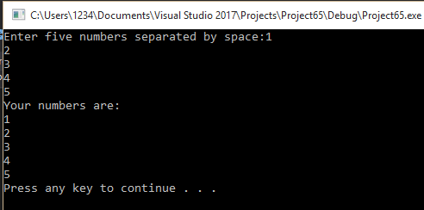

**Task 2:**

1. Write a program to sort an array of ten integer values in ascending order.

**Code:**

#include<iostream>

using namespace std;

int main()

{

int arr[10];

int *ptr;

int temp;

for (int i = 0; i < 10; i++)

{

cin >> arr[i];

}

for (int i = 0;i < 10;i++)

{

for (int j = i + 1;j < 10;j++)

{

if (arr[i] > arr[j])

{

temp = arr[i];

arr[i] = arr[j];

arr[j] = temp;

}

}

}

ptr = arr;

cout << "{ ";

for (int i = 0;i < 10;i++)

{

cout << *(ptr + i) << ", ";

}

cout << "}" << endl;

system("pause");

return 0;

}

**Output:**

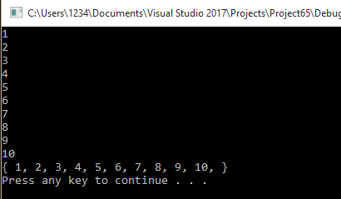

**Task 3:**

1. Write a C++ program that swap elements using call by reference.

**Code:**

#include<iostream>

using namespace std;

void swapping(int*, int*);

int main()

{

int a;

int b;

cout << "enter first number : ";

cin >> a;

cout << "enter second number : ";

cin >> b;

cout << "before swapping number 1 was : " << a << endl;

cout << "before swapping number 2 was : " << b << endl;

cout << "____________________________________" << endl;

swapping(&a, &b);

cout << "after swapping number 1 was : " << a << endl;

cout << "after swapping number 2 was : " << b << endl;

system("pause");

return 0;

}

void swapping(int*ptr, int*ptr2)

{

int temp;

temp = *ptr;

*ptr = *ptr2;

*ptr2 = temp;

}

**Output:**

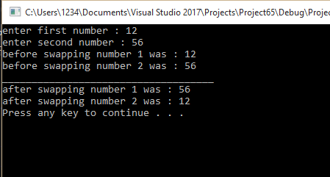

**Task 4:**

1. Write a C++ program to find maximum number between two numbers using a pointer.

**Code:**

/*#include<iostream>

using namespace std;

int main()

{

int num1, num2;

int*ptr1;

int *ptr2;

ptr1 = &num1;

ptr2 = &num2;

cout << "enter 2 number : ";

cin >> num1;

cin >> num2;

if (*ptr1 > *ptr2)

{

cout << num1 << " is maximum.";

}

else if (*ptr2 > *ptr1)

{

cout << num2 << "is maximum.";

}

system("pause");

return 0;

}

**Output:**

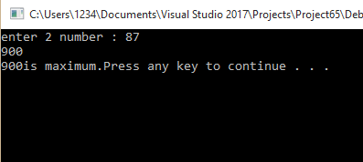

**Task 5:**

1. Write a C++ program to convert kilograms into grams by passing pointers as arguments to function.

**Code:**

#include <iostream>

using namespace std;

double convert(double* kilograms);

int main()

{

double kilograms;

cout << "Enter kilograms: ";

cin >> kilograms;

cout << kilograms << " kilogram(s) = " << convert(&kilograms) << " gram(s).\n";

system("pause");

return 0;

}

double convert(double* kilograms)

{

return *kilograms * 1000;

}

**Output:**

